JVNMOBILEGIS USER GUIDE
Prepared by: Khanh Le
Date: June 2008
Application version: 1.0.2
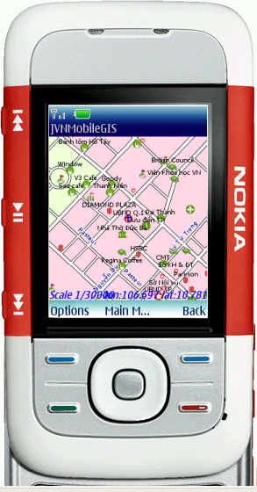

1. Introduction
JVNMobileGIS is a mobile map viewer developed with Java ME technology. It supports getting map data from remote server to view on mobile device.
JVNMobileGIS uses OGC (Open Geospatial Consortium - http://www.opengeospatial.org/ ) and JCP (The Java Community Process - http://jcp.org/ ) standards.
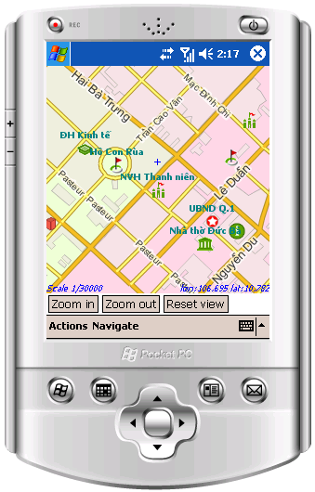
Figure 1. JVNMobileGIS on Windows Mobile
You can get all files and information about JVNMobileGIS at project homepage: http://code.google.com/p/jvnmobilegis/

2. Requirements
- Java mobile devices with MIDP 2.0/CLDC 1.0
- Internet connection (e.g. GPRS)

3. Features
- Get data from any OGC WMS compliant server on the Internet.
- HTTPS, SSL connection with secured map servers.
- GZIP transmission.
- Simple caching of map data in memory.
- Interactions on map view: Zoom in, zoom out, re-center map to the cursor point, drag, etc.
- OGC WMS GetFeatureInfo to view detail information of a map feature.
- Save map image to file.
- Multi-languages.
- Touch-screen support (e.g. Pocket PC, UIQ, etc.).

4. Installation

4.1. On real mobile devices (mobile phone, pocket PC, PDA)
The installation steps depend on your phone model and manufacturer. Please refer to your device specifications and manual for detail information.
Basically, you have 2 ways to install application on mobile devices:
- Over the Air installation
You can enter this URL http://jvnmobilegis.googlecode.com/svn/JVNMobileGIS.jad to your phone browser and follow all instructions given.
- PC Connection
Connect your phone to your computer through cable, bluetooth, infrared or Wifi. Copy the JVNMobileGIS.jar file to your phone, open it and install. Some phones need you to copy the JVNMobileGIS.jad file too.

4.2. PC Emulation
You can emulate JVNMobileGIS application in your PC by:
- Executable version
Download executable package from Download (http://code.google.com/p/jvnmobilegis/downloads/list ) page, extract and run JVNMobileGIS.exe
- Live Demo
You can run JVNMobileGIS on your PC at http://code.google.com/p/jvnmobilegis/wiki/LiveDemo
- Build from source
Using Sun Java Wireless Toolkit or IDE. Developers should already know about this. Refer to 'JVNMobileGIS Developer Guide' document for more information.

5. Getting Layers
1. Launch JVNMobileGIS  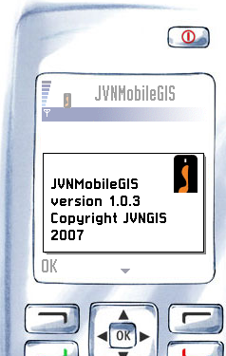  Figure 2. Welcome screen | 2. Choose 'Map Server' item in Main Menu  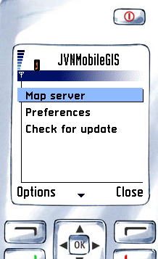  Figure 3. Main menu
3. Input your GetCapapilities URL of a map server or select it from pre-defined WMS Server URLs in menu.  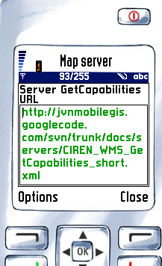  Figure 4. Map Server screen | 4. Choose GetCapabilities from menu  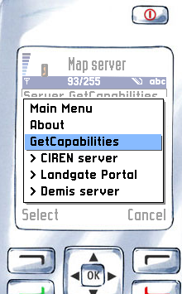  Figure 5. GetCapabilities menu

5. JVNMobileGIS will connect to entered WMS server to get Capabilities document. Device may ask for your permission before create the connection.  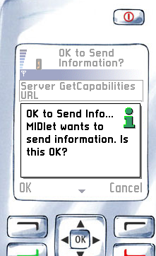  Figure 6. Permission confirmation | 6. Allow JVNMobileGIS to send information. Processing will take time to complete. You can Stop it at anytime by pressing Stop  .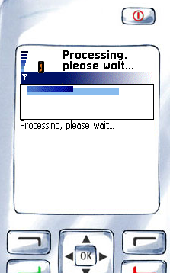  Figure 7. Processing indication
7. Once the requesting completed, you will see a list of available layers on WMS server. You can choose which layers you want to get in the map. In next screen, you can sort selected layers if you want (only since v1.0.3)  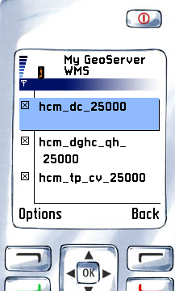  Figure 8. Layers listing | 8. If you are happy with selected layers, choose menu 'Get Map' to fetch map image from WMS server.  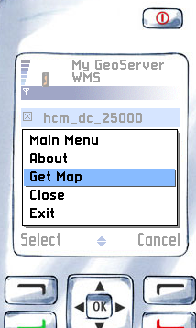  Figure 9. Get Map action

6. Map viewing
9. The map will be fetched and shown in a map canvas at global scaling  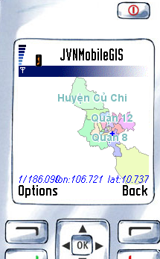  Figure 10. Map View canvas | 10. Map interactions  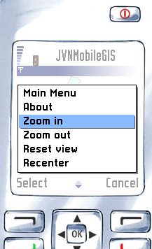  Figure 11. Map interactions  You can do some actions with the map:  + Zoom in  + Zoom out  + Reset view: reset to global view  + Recenter: Re-center the map at cursor position  + Refresh
11. At Map View canvas, select menu 'GetFeatureInfo' to get information of feature at cursor position. You will be asked for which layer to get information if this is the first time you use this function.  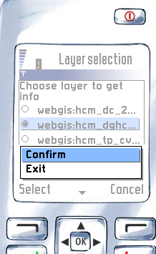  Figure 12. Confirm layer to get info | 12. Select the layer and Confirm. If there is an feature under your cursor, you will be able to see its detail information.  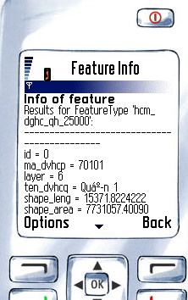  Figure 13. Detail information of a feature

13. In Map View canvas, you can also search for a feature inside current bounding box. Choose ' Search Feature' menu item to use this function (Note: this function is only applicable to Ho Chi Minh city map on CIREN server).  Enter text to Search form. The text is case-sensitive.  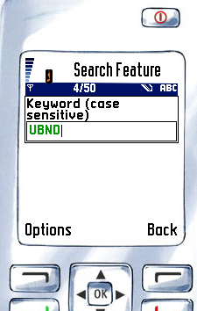  Figure 14. Search form | 14. If there are matching features in current bounding box, JVNMobileGIS will list them in result list.  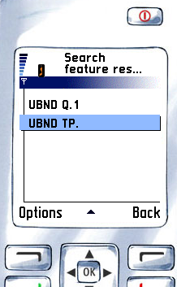  Figure 15. Search results
15. You can press phone's action button or choose 'View on map' menu to view selected item on the map canvas.  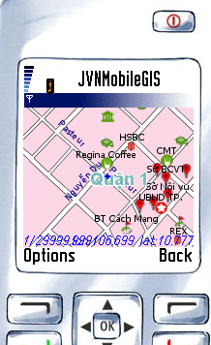  Figure 16. View the result on map | 16. You can even save map image to a file on your device (experimental, only since v1.0.3)

7. Preferences
17. You can go back to Main Menu by choosing 'Main Menu' item in your screen at any time.  Select 'Preferences' in Main Menu to change your preferences.  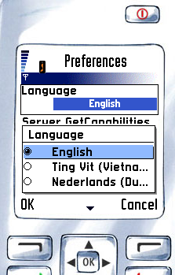  Figure 17. Language choosing at Preferences screen | 18. You can change your language and default WMS GetCapabilities URL (ignore 'WebGIS URL' value for now).  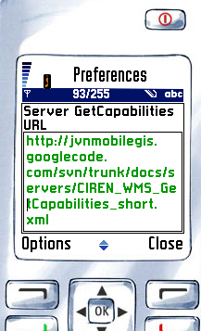  Figure 18. Change default GetCapabilities URL
19. Select 'Save' if you agree with your preferences
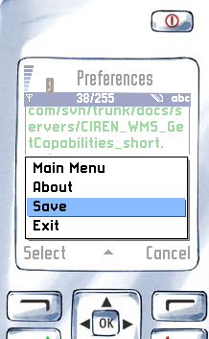
Figure 19. Save your preferences

6. Help and Check for update
20. If you need any help, go back to Main Menu and select Help or select Help menu at any screen.  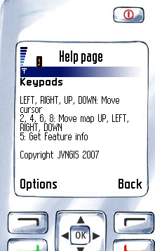  Figure 20. Help screen | 21. If you want to keep updated with latest version of JVNMobileGIS, go to Main Menu and select 'Check for update' to see if there's a newer version available.  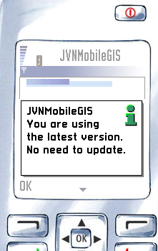  Figure 21. Check for update information

9. Troubleshooting

Cannot install
Check if your phone is MIDP 2.0 and CLDC 1.0 (or above). If you install via OTA, make sure you typed the URL correctly and your phone can connect to Internet to get the application.

Cannot connect
Check if you allow JVNMobileGIS to make connection. If you already allowed, check if map server is still up.

10. Abbreviations
- OGC - Open GIS Consortium
- JCP - Java Community Process
- GIS - Geographic information system
- WMS - Web Map Server
- Feature - map feature object
- MIDP - Mobile Information Device Profile
- CLDC - Connected Limited Device Configuration
- GPRS - General Packet Radio Service

11. Support
- FAQ - http://code.google.com/p/jvnmobilegis/wiki/FAQ
- Discussion forum - http://groups.google.com/group/JVNMobileGIS

